**Excel Assignment - 8**

1. **What do you mean by AutoComplete feature in Excel and what are the benefits of using this feature?**

This feature examines the contents of the active column in the data directly above and tries to anticipate what you are about to type.  
AutoComplete is the automatic filling in of your text when you start typing and is switched on by default.  
This will reduce the amount of text you have to enter by preventing you typing in repetitive words.  
AutoComplete matches only exact cell entries, not individual words in a cell. This does not work when entering or editing formulas.

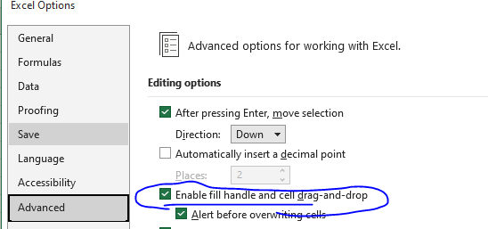

1. **Explain working with workbooks and working with cells.**

An Excel file, often referred to as a *workbook*, contains one or more spreadsheets, or *worksheets*. Each box in the worksheet area is referred to as a *cell*. Each cell has a *cell* *address*, which is composed of a *column reference* and a *row reference*. The letters across the top of the worksheet make up the column reference. The numbers down the left side of the worksheet make up the row reference. For example, the address of the top, leftmost cell is A1. This is because the cell is located at the intersection of the A column and row 1.

### Explore Worksheets

1. Open Excel and open a new Blank workbook.

[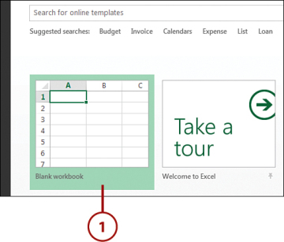](javascript:popUp('/content/images/chap1_9780789750754/elementLinks/01fig09_alt.jpg'))

* 1. The workbook opens with one worksheet called Sheet1. This worksheet contains cells you can use to start entering and editing data.
  2. Click the plus icon to add a new worksheet.

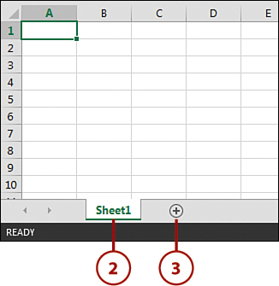

1. The new worksheet is added and named Sheet2. Each time you add a worksheet, Excel gives the worksheet a default name of Sheet XX, where XX is the next sequential number.
2. **What is fill handle in Excel and why do we use it?**

‘Fill Handle’ is a tool that you can use to autocomplete lists in Excel.

For example, if you have to enter numbers 1 to 20 in cell A1:A20, instead of manually entering each number, you can simply enter the first two numbers and use the fill handle to do the rest.

AD

1. **Give some examples of using the fill handle.**

Suppose you have the data as shown below:

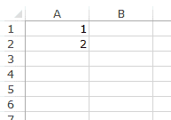

AD

Here are the steps to use the fill handle to quickly insert numbers up to 20.

* Select the data set.
* Hover the mouse over the bottom-right edge of the selection, you would see a plus icon appear – How to Use Fill Handle in Excel - Plus Icon Small
* Click the left button on the mouse and drag it down. Excel identifies a pattern of the first 2 numbers (an increment of 1) and uses that to fill that entire series.

AD

If you have data in the adjacent column, you can also hover the mouse over the right edge of the selection and double click. It will automatically fill the list to the last cell based on the data in the adjacent column.

For example, if I double-click on the fill handle (as shown below), it will fill the column till cell A11 (since there is data until cell B11 in the adjacent column.



## Examples of Using Fill Handle in Excel

In the above examples, we saw how to use fill handle in excel to complete the list of numbers (that increment by 1).

AD

There are many more situations when a fill handle can automatically detect the pattern and fill the cells.

Here are the inbuilt fill handle patterns you can use:

### Autofill Numbers that Increment/Decrement by 1

As shown above, you can quickly fill cells when the number increments/decrements by 1.

AD



Note that the fill handle works in both directions. You can either fill down by dragging it down or fill up the dragging it upwards.

AD

### Autofill Weekday Names

You can use fill handle in Excel to autocomplete weekday names. It could either be the three alphabets nomenclature (Mon, Tue…) or the full name (Monday, Tuesday…).



Note that it fills the cells with 7 weekdays names and then start over with the same name where you started. For example, in the above example, it starts with Monday, and after Sunday it again automatically inserts Monday.

### Autofill Dates

You can easily autofill dates using the fill handle in Excel. Any date format that is recognized by Excel can be used by the fill handle.

AD



## Auto Fill Options

While fill handle recognizes patterns and fills the list, it also gives some additional options you can use.

As soon you drag the mouse (or double click) and autocomplete the list, you will see the Autofill option icon at the bottom right of the list.how to use fill handle in excel - Autofill Option Icon

AD

When you click on this icon, a list of options becomes available. These options are different for different types of data (numbers, dates, days).

### Autofill Options for a List with Numbers

When you use the fill handle to autocomplete a list of numbers, you will see the Auto Fill Options icon at the bottom right. Click on that icon to see additional options.



AD

Let’s go through these options:

* **Copy Cell**: If you select this option, it will simply copy-paste the cells.
* **Fill Series**: This is the default option where it fills the series based on the pattern it recognizes. In the example below, it fills the cells with numbers incrementing by 1.
* **Fill Formatting Only**: This option only fills the formatting and not the values.
* **Fill Without Formatting**: This option fills the cells based on the recognized pattern but does not copy the formatting. In the example, below, when this option is selected, it doesn’t apply the border and color to the filled cells.
* **Flash Fill**: This is a new feature available in Excel 2013 only. It deduces the pattern to complete the list based on the values in adjacent cells.

### Autofill Options for a List with Dates

In case you are using the fill handle to autocomplete dates, additional options become available in the autocomplete options.

AD



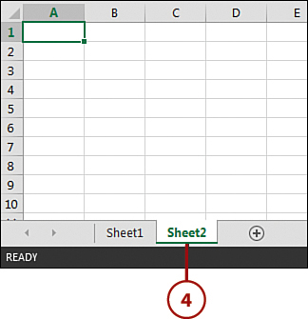

1. **Describe flash fill and what the different ways to access the flash fill are.**

Flash Fill easily copes with dozens of different tasks that otherwise would require complex formulas or even VBA code such as splitting and combining text strings, cleaning data and correcting inconsistencies, formatting text and numbers, converting dates to the desired format, and a lot more.

Each time, Flash Fill combines millions of small programs that might accomplish the task, then sorts those code snippets using machine-learning techniques and finds the one that suits best for the job. All this is done in milliseconds in the background, and the user sees the results almost immediately!

In Excel 2013 and later, the Flash Fill tool resides on the Data tab, in the Data tools group:  
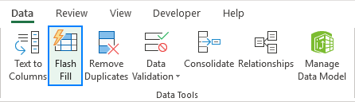

## **Excel Flash Fill shortcut**

Those of you who prefer working from a keyboard most of the time, can run Flash Fill with this key combination: Ctrl + E

## **use Flash Fill in Excel**

Usually Flash Fill starts automatically, and you only need to provide a pattern. Here's how:

1. Insert a new column adjacent to the column with your source data.
2. In the first cell of a newly added column, type the desired value.
3. Start typing in the next cell, and if Excel senses a pattern, it will show a preview of data to be auto-filled in the below cells.
4. Press the Enter key to accept the preview. Done!

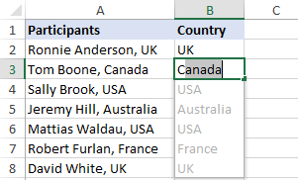

### **Flash Fill in Excel with a button click or shortcut**

In most situations, Flash Fill kicks in automatically as soon as Excel establishes a pattern in the data you are entering. If a preview does not show up, you can activate Flash Fill manually in this way:

1. Fill in the first cell and press Enter.
2. Click the Flash Fill button on the *Data* tab or press the Ctrl + E shortcut.

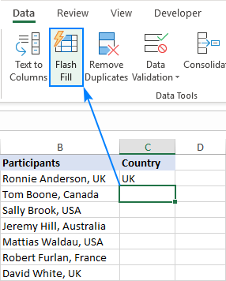

## Excel Flash Fill options

When using Flash Fill in Excel to automate data entry, the Flash Fill Options button appears near the auto-filled cells. Clicking this button opens the menu that lets you do the following:

* Undo the Flash Fill results.
* Select blank cells that Excel has failed to populate.
* Select the changed cells, for example, to format them all at once.

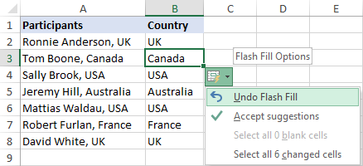

1. **Extract first name and last name from the mail id and then from the address column, extract the city, state, and pin code using the flash fill. Given below is an example of the columns you have to create. Paste the screenshot of what you have created using the flash fill command. Example: Mail Id, Address, First name, Last name, State, City, Pin code.**

